**GRID**

Landing Page – 1440px

Portal – 1170px

**COLOR PALETTE**

|  |  |  |
| --- | --- | --- |
| **0091E5** | **FF6347** | **34BB62** |
| **999999** | **EDEFF2** | **DADADA** |
| **A3A5A8** | **000000** |  |
|  |  |  |
| |  |  | | --- | --- | |  |  | | |  |  |

**TYPOGRAPHY**

**Font Awesome**

**Text 30**  Text 30

**Text 25** Text 25

**Text 20** Text 20

**Text 15** Text 15

**FORMS**

Empty



Error

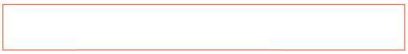

**BUTTONS**

   

PAGINATION PAGE UP SANDWICH





EDIT ICON